LC=Lynnette Carter
SS = Stephanie Solazzo
SH = Sherri Haggerty

EN = Erin Nunley
BS = Brandi Sweatman
MS = Michelle Starnes
BD = Brook Diaz

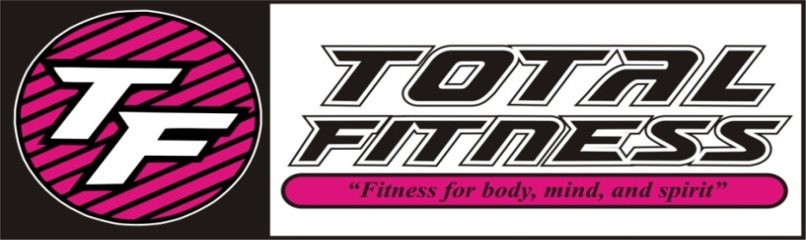
SEPTEMBER 2018 CLASS SCHEDULE
TIME | MONDAY | TUESDAY | WEDNESDAY | THURSDAY | FRIDAY
8:30 AM | (SS) Yoga Fitness | (LC) Pure Strength | (LC) HIIT | (LC) Pure Strength | (SS) Yoga LIIT
9:30 AM | (SS) SS Yoga | (SH) SS Classic | (LC) SS Cardio | (SH) SS Classic | (LC) SS Cardio
10:30 AM | (BS) Line Dance | (SH) Pilates/Stretch | (BS) Line Dance | (SH) Pilates/Stretch | (BS) Line Dance
11:15 AM |  | (SH) Water Aerobics |  | (SH) Water Aerobics
4:00 PM |  | Fit Kids 4-12 |  | Fit Kids 4-12
5:00 PM |  |  |  | (BD) Pure Strength
5:30 PM | (SS) Yoga |  | (SS) Yoga
6:00 PM |  | (MS) Fat Blaster |  | (MS) Fat Blaster
7:00 PM | (EN) Zumba | (EN) Zumba Step | (EN) Boot Camp

SS Classic-Silver Sneakers class- Muscle Strength & Range of Movement will help to improve agility, balance, coordination and activities for daily living, using a chair, ball, free weights, and bands.
SS Yoga Stretch-Silver Sneakers class will move your whole body through a complete series of seated and standing yoga poses designed to increase flexibility, balance and range of movement.
SS Cardio -Silver Sneakers All welcome this class will include strength training and range of motion with cardio intervals.
Fat Blaster-This class will blast fat cells and burn calories, using multiple disciplines including circuit, intervals, kickboxing, and step!
Fit Kids – Ages 4 – 12 a fun filled interactive age appropriate class to keep your child moving aerobically by playing games, dancing and challenging obstacle courses!
Yoga-Classes that will stretch your mind, body, and spirit, several modifications are taught to make your experience as relaxed or challenging as you like.
Yoga Fitness-A combination of yoga poses with small weights and movement.
Zumba-Latin inspired dance-fitness with cardio-based dance movements that are easy to follow. No dance experience required!
Zumba Step-Latin inspired dance moves with an added step up, maximizing lower body results, torching even more calories!
Pure Strength-Designed to build strength, add definition, increase bone density, and decrease body fat by increasing your lean muscle which will in turn speed up your metabolism. No muscles get neglected in this class!
Line Dance-Great cardio work out with fun music and line dances to keep you moving!
Pilates/Stretch-This class is empowering and combines a sequence of Pilate moves, and stretching.
Yoga LIIT-Low Intensity Interval Training-This class is a low impact total body yoga style workout, using isometric and small movements to target and tone your seat, hips, thighs, abs, arms and improve your posture. Leading to long lean muscles!
HIIT-High Intensity Interval Training-This is a high intensity, full body work out which involves a series of repeated bouts of short duration high intensity exercise interspersed with varied recovery periods. This is a great cardio and fat burning class.
Boot Camp-Full body work out using a variety of tools to get fit! Burning fat while adding muscle and endurance.
Water Aerobics- Exercise in the fun of the pool! Full body work out invigorating and aerobic.

