LC=Lynnette Carter
SS = Stephanie Solazzo
SH = Sherri Haggerty

KK=Kim King
EN = Erin Nunley
BD = Brooke Diaz
BS = Brandi Sweatman

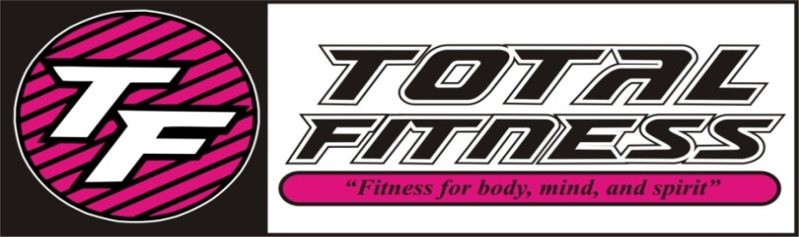
JUNE 2017CLASS SCHEDULE
TIME | MONDAY | TUESDAY | WEDNESDAY | THURSDAY | FRIDAY | SATURDAY
8:30 AM | (SS) Yoga Fitness | (LC) Strength | (LC) HIIT | (LC) Strength | (SS) LIIT
9:30 AM | (SS) SS Yoga | (SH) SS Classic | (LC) SS Cardio | (SH) SS Classic | (LC) SS Cardio
10:30 AM | (BS) Boom Move It | (SH) Water Aerobics | (BS) Boom Move It | (SH) Water Aerobics | (BS) Boom Move It
4:00 PM |  | (SS) Fit Kids 4-12 |  | (SS) Fit Kids 4-12 | (SS) Fit Kids 4-12
4:30 PM | (SS) LIIT |  | (SS) LIIT | (SS)
5:30 PM | (SS) Yoga |  | (SS) Yoga
6:00 PM |  | (KK) Fat Blaster |  | (KK) Fat Blaster
7:00 PM | (EN) Zumba | (EN) Zumba Step |  | (BD) House Party Fitness

SS Classic-Silver Sneakers class- Muscle Strength & Range of Movement will help to improve agility, balance, coordination and activities for daily living, using a chair, ball, free weights, and bands.
SS Yoga Stretch-Silver Sneakers class will move your whole body through a complete series of seated and standing yoga poses designed to increase flexibility, balance and range of movement.
SS Cardio -Silver Sneakers All welcome this class will include strength training and range of motion with cardio intervals.
Fat Blaster-This class will blast fat cells and burn calories, using multiple disciplines including circuit, intervals, kickboxing, and step!
Fit Kids – Ages 4 – 12 a fun filled interactive age appropriate class to keep your child moving aerobically by playing games, dancing and challenging obstacle courses!
Yoga-Classes that will stretch your mind, body, and spirit, several modifications are taught to make your experience as relaxed or challenging as you like.
Yoga Fitness-A combination of yoga poses with small weights and movement.
Zumba-Latin inspired dance-fitness with cardio-based dance movements that are easy to follow. No dance experience required!
Zumba Step-Latin inspired dance moves with an added step up, maximizing lower body results, torching even more calories!
House Party Fitness-Enjoy hip hop beats with moves that target the areas of your body that you want toned, and the cardio will melt the fat away.
Pure Strength-Designed to build strength, add definition, increase bone density, and decrease body fat by increasing your lean muscle which will in turn speed up your metabolism. No muscles get neglected in this class!
Boom Move IT-Great cardio work out with fun music and moves to keep you moving!
Boom Mind-an empowering class that combines the best of yoga Pilates, and stretching.
LIIT-Low Intensity Interval Training-This class is a low impact total body workout, using isometric and small movements to target and tone your seat, hips, thighs, abs, arms and improve your posture. Leading to long lean muscles!
HIIT-High Intensity Interval Training-This is a high intensity, full body work out which involves a series of repeated bouts of short duration high intensity exercise interspersed with varied recovery periods. A great cardio and fat burning class.
Water Aerobics-Join us in the water for a great cardio and strengthening work out!

