LC=Lynnette Carter
KK=Kim King
SS = Stephanie Solazzo
RP = Rachel Peaks
SH = Sherri Haggerty

HM = Heather Manire
EN = Erin Nunley
BD = Brooke Diaz
MD = Madison Perkins
TS = Terri Skipper
AL = Aliza Lee

Li

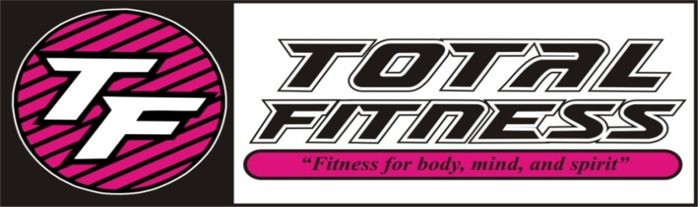
April 2016 CLASS SCHEDULE
TIME | MONDAY | TUESDAY | WEDNESDAY | THURSDAY | FRIDAY | SATURDAY
8:30 AM | (SS) Yoga Fitness | (LC) Pure Strength | (LC) Step Up | (LC) Pure Strength | (AL) Zumba
9:30 AM | (SS) SS Yoga | (RP) SS Circuit | (LC) SS Classic | (RP) SS Cardio | (SH) SS Classic | (TS) Pound
10:30 AM | (AL) Zumba Gold | (RP) House Party Fitness | (LC) Classical Stretch | (RP) House Party Fitness | (SH) Classical Stretch | (EN) Zumba Toning
4:00 PM |  | (MP) Kids Aerobics |  | (MP) Kids Aerobics | (MP) Kids Aerobics
4:30 PM |  |  | (RP) Tabata | (AL) Cardio Fitness
5:30 PM | (SS) Yoga |  | (SS) Yoga
6:00 PM | 080597 | (KK) Fat Blaster |  | (KK) Fat Blaster | (EN) Zumba
7:00 PM | (HM) Zumba | (HM) Zumba | (TS) Pound | (BD) House Party Fitness

SS Classic-Silver Sneakers class- Muscle Strength & Range of Movement will help to improve agility, balance, coordination and activities for daily living, using a chair, ball, free weights, and bands.
SS Yoga Stretch-Silver Sneakers class will move your whole body through a complete series of seated and standing yoga poses designed to increase flexibility, balance and range of movement.
SS Cardio Circuit-Silver Sneakers All welcome this class will include strength training and range of motion with cardio intervals.
Fat Blaster-This class will blast fat cells and burn calories, using multiple disciplines including circuit, intervals, kickboxing, and step!
Kids Aerobics-A fun filled class to keep your child moving aerobically by playing games, dancing and challenging obstacle courses!
Yoga-Classes that will stretch your mind, body, and spirit, several modifications are taught to make your experience as relaxed or challenging as you like.
Yoga Fitness-A combination of yoga poses with small weights and movement.
Zumba-Latin inspired dance-fitness class with cardio-based dance movements that are easy to follow. No dance experience required!
Zumba Toning-Same dance add some light weights for extra toning.
Zumba Gold-This class is the Zumba you love modified at lower-intensity for the active older adult!
House Party Fitness-Enjoy hip hop beats with moves that target the areas of your body that you want toned, and the cardio will melt the fat away.
Pure Strength-Designed to build strength, add definition, increase bone density, and decrease body fat by increasing your lean muscle which will in turn speed up your metabolism. No muscles get neglected in this class!
Tabatta-A variety of simple, yet intense timed exercises, each class will blast the calories and provide noticeable results.
Step Up-A class using steps in a variety of ways to build muscle and endurance. This will have modifications for all fitness levels.
Pound-Combines light resistance with constant simulated drumming movements torching 400 – 900 calories per class!
Classical Stretch-Rebalance your body, increase mobility and keep joints healthy with this full body dynamic stretching exercises.
Mix & Max-You will mix up your routines and max the body out! Be prepared for a great full body work out with lots of variety.
Cardio Fitness-Energize your day with fun filled cardio moving to music.

